Abstraction in Java

🔹 Definition
Abstraction in Java is the process of hiding internal implementation details and showing only the essential features of an object.
Or
Abstraction means showing only necessary information and hiding the internal implementation from the user.
Real-Life Example
- When you use a UPI app (like Google Pay), you just click Send Money.
You don’t know how encryption, verification, or server calls happen in the backend — that’s abstraction.

🔹 Technical Explanation
In Java, abstraction is achieved using:
- Abstract Classes
    - Created by abstract keyword
    - Can have instance variables
    - Can have constructors
    - Can have abstract methods or non-abstract methods
    - Body of a abstract method will be created in its child class
- Interfaces
    - Created by interface keyword
    - Only have abstract methods
    - Body of abstract methods is created in it’s implements
They help in building scalable, modular, and secure software.

🧩 1️⃣ Abstract Class Example (Industry-level)
Scenario: Banking System
Let’s say you are developing software for multiple banks — SBI, HDFC, and ICICI.
Each bank calculates interest differently but all follow a general process.
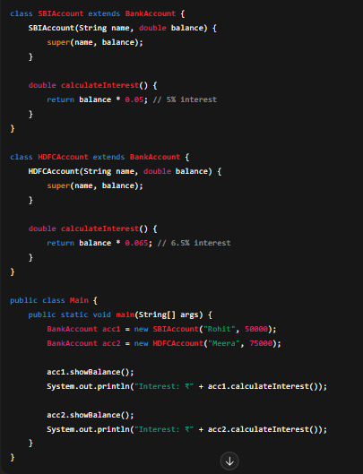

Why this is industrial:
- Every banking client has a different interest logic.
- But the core structure (balance, accountHolder) remains same — abstract class defines that common skeleton.

2️⃣ Interface Example (Industry-level)
Scenario: Online Payment Gateway Integration

In e-commerce systems, you integrate different payment gateways — Razorpay, Stripe, PayPal, etc.
All follow similar methods like pay() and refund().
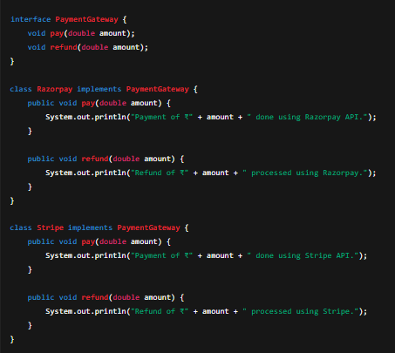
Why this is industrial:
- In real-world systems, developers integrate multiple APIs (Razorpay, Stripe, PayPal).
- Interface ensures every provider follows same standard — no matter what happens internally.

3️⃣ Mixed Use Case (Abstract Class + Interface)
Scenario: Notification System (Email, SMS, WhatsApp)
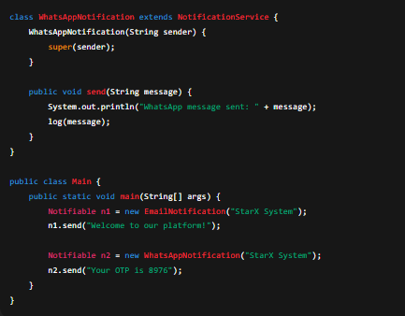
When a user registers, you may send notifications through multiple channels.
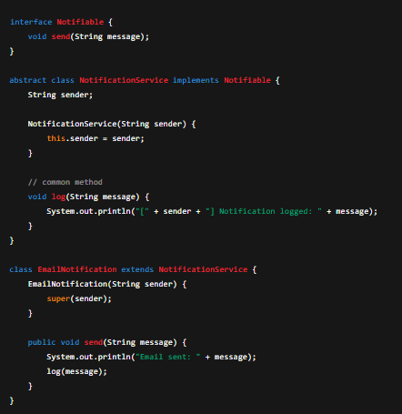

Industrial Relevance:
- Every modern app (Swiggy, Zomato, Amazon, etc.) uses notification services like this.
- Interface defines "what should happen" (send() method).
- Abstract class provides common reusable logic (log() method).

